Review What You Learned

In this course, you explored generative AI techniques and their applications in data science. You learned about integrating generative AI into data science projects, including data augmentation and feature engineering. You also learned how to use and apply generative models for tasks such as data generation, augmentation, preparation, querying, and more.

Here are the key takeaways from this course:

Generative AI empowers data scientists to generate entirely new data, unlocking a universe of possibilities and tackling previously insurmountable challenges.

There are four standard generative AI models: Generative adversarial networks (GANs), variational autoencoders (VAEs), autoregressive, and flow-based models.

While GANs are great at data augmentation, VAEs are good at anomaly detection, data compression, collaborative filtering, and style transfer.

Autoregressive models are good at text generation, speech synthesis, time series forecasting, and machine translation, and flow-based models are suitable for image and data generation and density estimation.

Generative AI can tackle complex problems across various industries.

Generative AI models are instrumental in tackling several data preparation and querying challenges, such as inputting missing values, detecting outliers, reducing “noise,” and translating natural language queries into equivalent SQL statements.

Generative AI can help in exploratory data analysis or EDA using various techniques, such as statistical data description, univariate, bivariate, multivariate analysis, feature engineering, and hypothesis generation.

Generative AI plays a significant role in developing a predictive model using various techniques, such as selecting model architecture and essential features, generating ensemble models, improving model interpretability and generalization, and preventing overfitting.

While using generative AI models, data scientists need to look into data, models, and ethical considerations.

Data professionals face various technical, organizational, and cultural challenges when using Generative AI in multiple industries.

Being a successful data scientist requires several skills, such as mathematical and statistical skills, knowledge of programming languages, and an understanding of machine learning principles.

Final Project

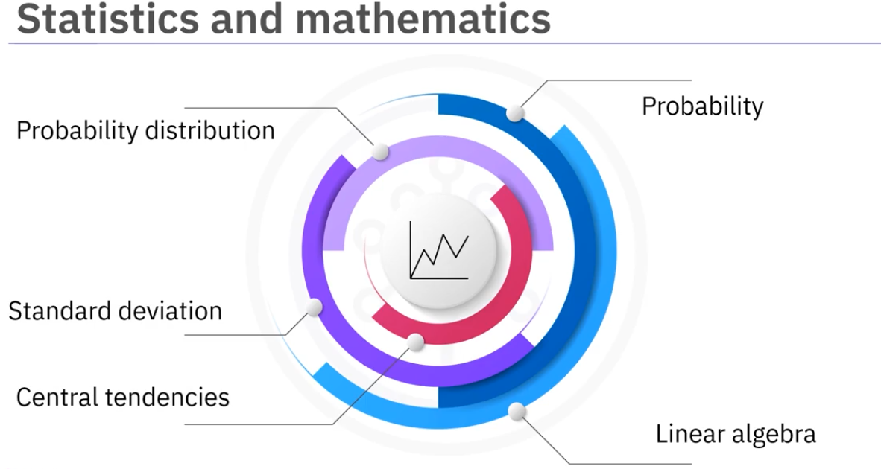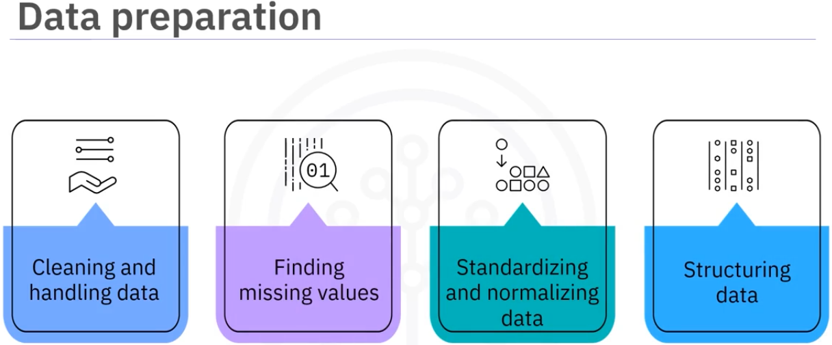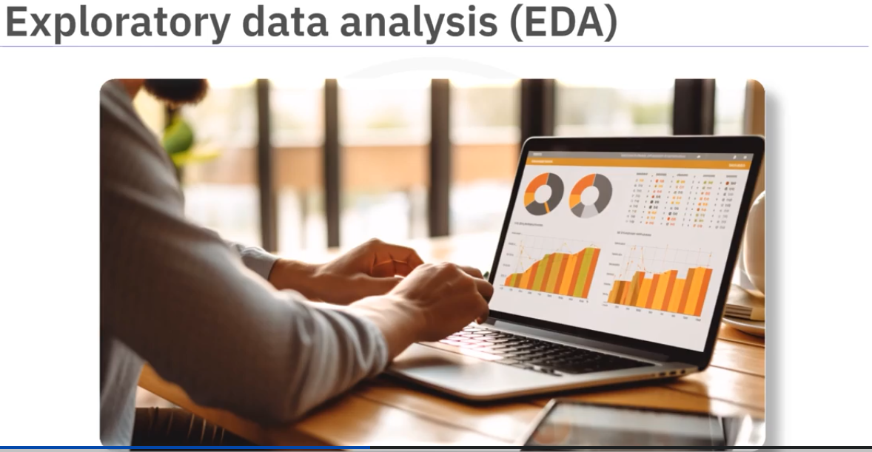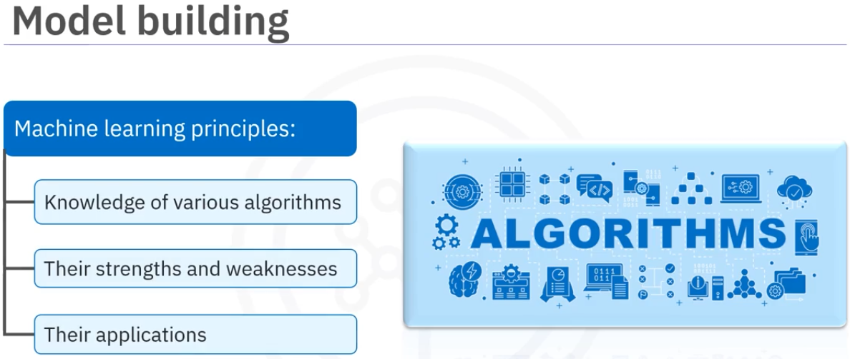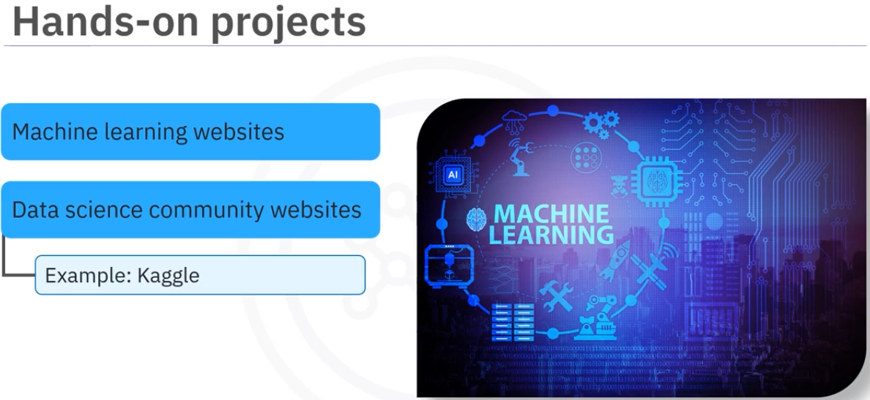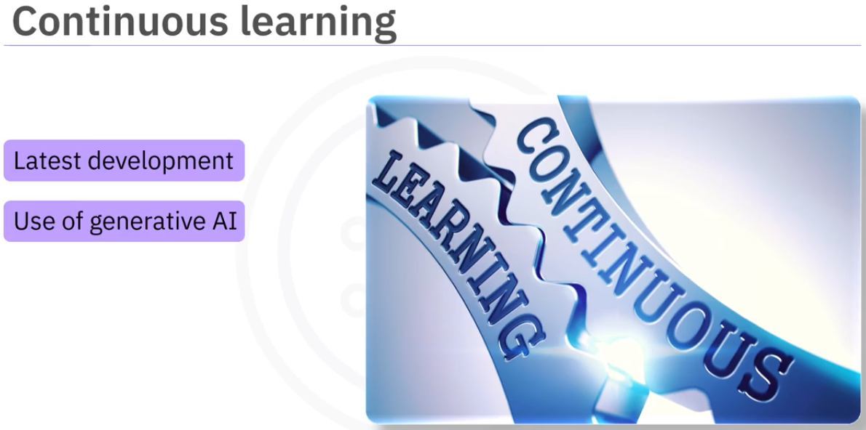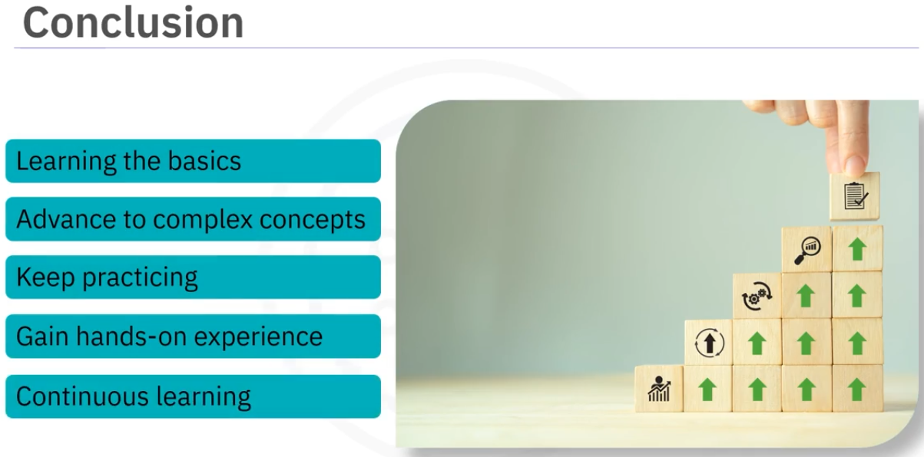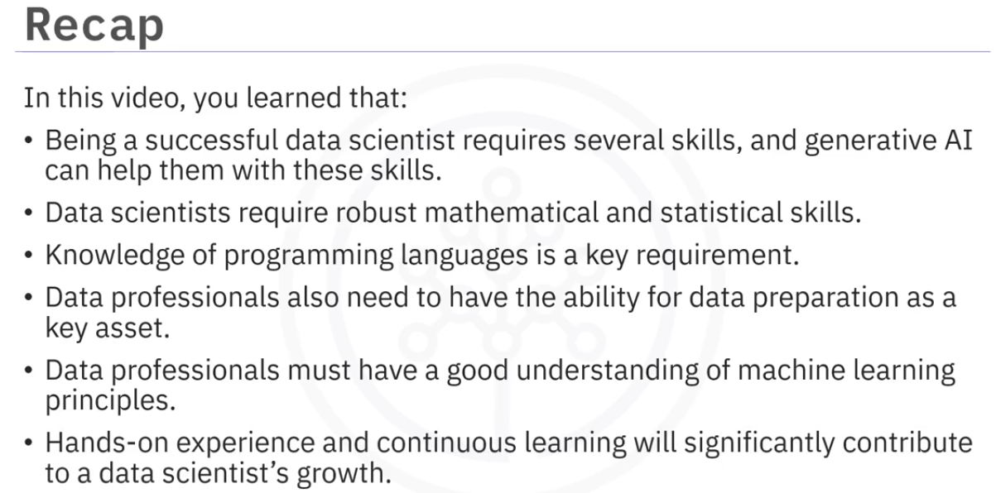

# Congratulations and Next Steps

Congratulations on completing this course. We hope you enjoyed it.

This course is part of IBM Generative AI for Data Scientists Specialization Certificate.

No experience is needed to begin this specialization, although you might find it helpful to have some knowledge of data science.

This specialization certificate has provided you with knowledge of generative AI models and tools for text, code, image, audio, and video generation.

The introductory courses in the Professional Certificate that precede this course are:

[Generative AI: Introduction and Applications](https://www.coursera.org/learn/generative-ai-introduction-and-applications" \t "/home/vastan1993/Documents\\x/_blank)

· · · [Generative AI: Prompt Engineering Basics](https://www.coursera.org/learn/generative-ai-prompt-engineering-for-everyone?" \t "/home/vastan1993/Documents\\x/_blank)

* ·

We encourage you to take the next step by pursuing other courses in generative AI and data science:

Generative AI: Data Analytics (to be released in January 2024)

[What is Data Science?](https://www.coursera.org/learn/what-is-datascience?skipBrowseRedirect=true" \t "/home/vastan1993/Documents\\x/_blank)

We encourage you to leave your feedback and rate this course so that we can continue to improve the course content.